GRADE 7 ACCELERATED  Unit 1 Assessment  Equations and Inequalities | Name_________________________  Date__________________________  Period________________________  Score __________ / 21

DIRECTIONS. Show your work for every question. Write repeating decimals with a bar over the digits that repeat. Fractions do not have to be in simplest form. Where a question gives units, include them in your answer.
1. Complete the table by writing the equivalent value in each empty cell. | 3 points

 | Fraction | Decimal | Percent
a. | 6/11
b. |  | 0.85
c. |  |  | 72%

2. Maria opens a package of Tropical Skittles. The package has five flavors: Banana Berry (yellow), Kiwi Lime (green), Mango Tangelo (orange), Pineapple Passion fruit (blue) and Strawberry Starfruit (pink). The table shows what part of Maria's package is each flavor. | 4 points

Flavor | Amount
Banana Berry | 20%
Kiwi Lime | 4/15
Mango Tangelo | 0.12
Pineapple Passion fruit | 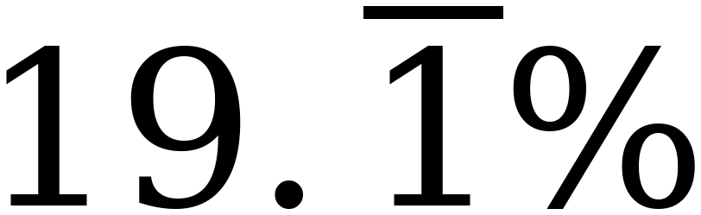
Strawberry Starfruit | 

a. What percentage of Maria's package is Mango Tangelo? | 1 point

Percentage

b. Rewrite the amount of Maria's package that is Kiwi Lime as a decimal. | 1 point

Decimal

c. What fraction of Maria's package is Strawberry Starfruit? | 1 point

Fraction

d. Rewrite the amount of Maria's package that is Banana Berry as a decimal. | 1 point

Decimal

3. Esmeralda is saving for a trip to Siesta Key. She is paid the same amount every week. Each week she uses $382 of her pay for her expenses and saves everything that is left. After 11 weeks she has saved $506. | 2 points

a. Write an equation that can be used to determine the amount, x, in dollars that Esmeralda is paid each week. | 1 point

Equation

b. Solve the equation. | 1 point

Solution

Solve each equation. Show your work.
4. −4(w + 7) = 108 | 1 point

Solution

5. n ÷ (−3) + 3.8 = −7.4 | 1 point

Solution

6. 3 ⅚ = 8 ⅕ − k | 1 point

Solution

7. A server at The Main Street Grill earns $7.80 per hour plus $87.40 in tips. | 2 points

a. Write an equation that can be used to determine the number of hours, h, the server worked to earn $136.15. | 1 point

Equation

b. Solve the equation. | 1 point

Solution

8. Circle every value below that is a solution to −3x + 4 ≤ 19. | 1 point

−8 | −6⅓ | −5 | −4.9 | 0 | 12.5

Solve each inequality. Show your work, then graph the solution set on the number line.
9. −11.3 > −3x − 0.5 | 1 point

Solution

10. ⅔ (21 − 15x) > 76 | 1 point

Solution

11. −8(5x + 9) ≥ 208 | 1 point

Solution

12. The drama club is renting a bus for a field trip. The bus company charges a flat fee of $260 plus $16 for each student who rides. The club has raised $1,000 and wants to take as many students as possible. | 3 points

a. Write an inequality that can be used to determine the number of students, s, who can ride the bus. | 1 point

Inequality

b. Solve the inequality. | 1 point

Solution

c. How many students can ride the bus? Justify your answer mathematically. | 1 point

